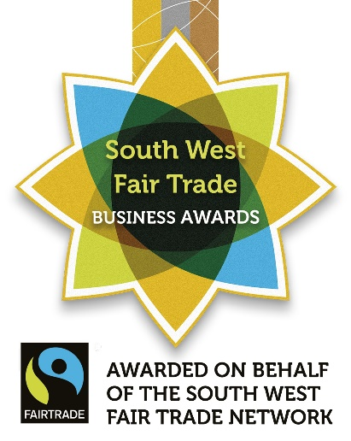
Use this template as the basis for a press release to local news outlets and networks. You might like to adapt it to mention which group is making the call for entries (eg. your local Fair Trade group), or to hook on to an event you’re running in relation to Fair Trade or the Awards (eg. a Fair Trade business breakfast). The first quote can be amended to better suit your own tone of voice.

—FOR IMMEDIATE RELEASE—

Call for [insert name of town] organisations to make Fair Trade their business

Local businesses are being urged to demonstrate their support for Fair Trade by entering the South West Fair Trade Business Awards. The ethical awards scheme, now entering its 8th year, celebrates organisations that support Fair Trade and encourages them to go the extra mile to embed Fair Trade values in their business.

The Awards are open to organisations of all sorts and sizes across the South West region, and there are now calls for more businesses in [insert name of town] to fly the flag for Fair Trade at the 2020 Awards ceremony, due to take place on Friday 15th May, shortly after World Fair Trade Day.

[Insert name of town] resident, [insert name (and group represented if relevant)] appealed to local businesses, saying:

“Organisations—no matter what sort of business they practise or how big they are—have enormous potential to do good in the world, both through what they purchase and sell, and in the way they engage their staff and customers. [I / we] know there’s already so much good work going on in [insert name of town]; it’s time for that to be recognised through the South West Fair Trade Business Awards and for more organisations to make Fair Trade part of their activity.”

With organisations under increasing pressure to use transparent supply chains and to demonstrate their ethical integrity, the awards offer a framework for organisations wishing to commit to a better way of doing business. The scheme is free to enter and rewards applicants on a sliding scale from bronze to gold, enabling even the smallest organisations to be involved.

Echoing calls for applicants, Danni Rochman, South West Fair Trade Business Awards coordinator, said:

“The awards are very much a local scheme with an international outlook. The collective spend on Fair Trade of our applicants each year—which reaches into the several millions of pounds—is testament to how organisations can play a part in a global movement that offers an alternative to poverty. At the same time, by shouting about the brilliant work that award winners are doing, we’re helping to raise their ethical profile and make a difference to the local economy too. We really urge every organisation in the region to consider entering the awards to show how fair and local can go hand in hand.”

Previous years have seen awards given to organisations as diverse as high street furniture shops, printers and cafés to large solicitor firms and food retailers, and even some of the region’s most renowned universities. Winners are celebrated in an annual ceremony, whose past hosts include Krishnan Guru-Murthy, Liz Earle MBE and, most recently, Nick Hewer.

Organisations wishing to find out more about the Awards can visit www.bristolfairtrade.org.uk/swftba. Applications open Monday 20th January and close Friday 3rd April 2020.

—ENDS—
NOTES TO EDITORS

- The South West Fair Trade Business Awards are organised and administrated by Bristol Fair Trade Network CIC on behalf of the South West Fairtrade region, with the support of Destination Bristol and South Gloucestershire Council.

- The South West Fairtrade region spans from Cornwall to Swindon. It is one of the leading Fairtrade regions in the UK.

- [Insert notes on your own group or organisation if relevant]

- Fair Trade certification schemes, such as the Fairtrade Mark, guarantee a fair minimum price for produce grown under Fair Trade terms, as well as safeguarding workers’ safety and rights. Goods bought through Fair Trade supply chains include a social premium to be used for the benefit of the wider community, as decided by local cooperatives. Fair Trade certification addresses climate change by supporting sustainable farming methods, through stringent controls on waste, carbon emissions and water use, and through training farmers in techniques that mitigate the effects of a changing global climate.

- Awareness of the Fairtrade Mark in 2015 was recorded as 93%, with a trust rate of 83%. 71% of shoppers use the Fairtrade mark to decide if a product is ethical [Fairtrade International Globe Scan Consumer Study 2015].

Images
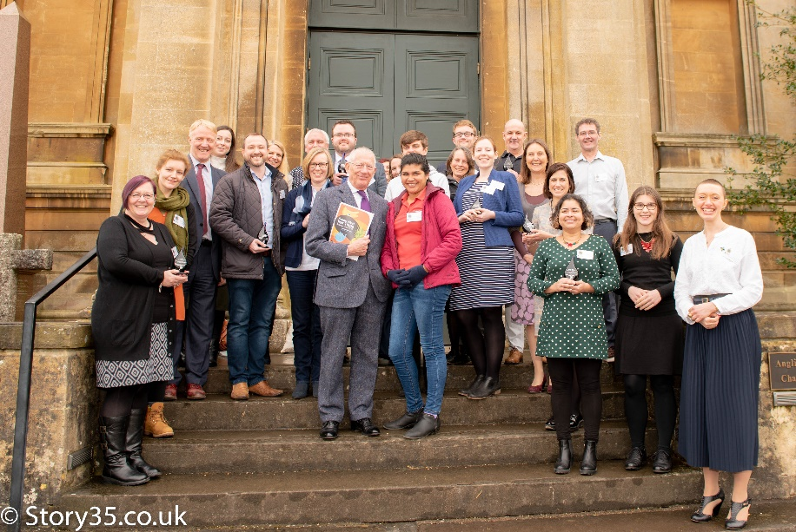
Winners at the 2019 South West Fair Trade Business Awards ceremony, with host Nick Hewer and Fairtrade farmer Junieth Leiva (centre)

Credit: Story 35

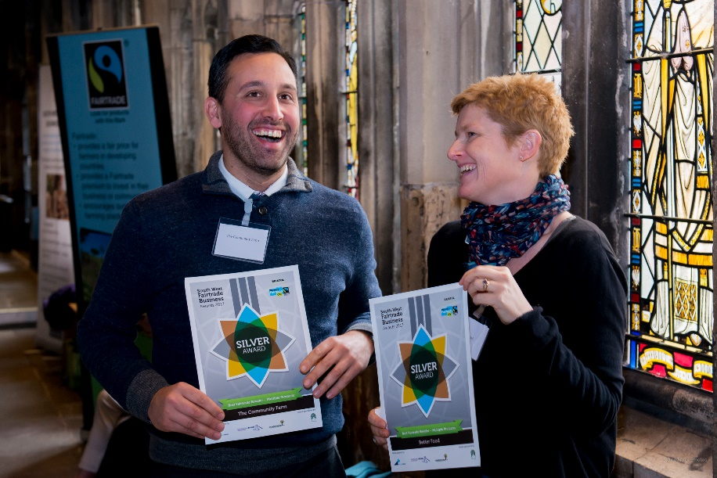
Delegates from businesses in the region celebrating their success at the South West Fair Trade Business Awards

Credit: Jon Craig

